

School: ............................................................................................................. Campus: ....................................................... Academic Year: ...................... Subject Name: ........................................................... Subject Code: ..........................

Semester: ............... Program: ........................................ Branch: ......................... Specialization: .......................... Date: .....................................

(Learning by Doing and Discovery)

**\* Coding Phase: Pseudo Code / Flow Chart / Algorithm**

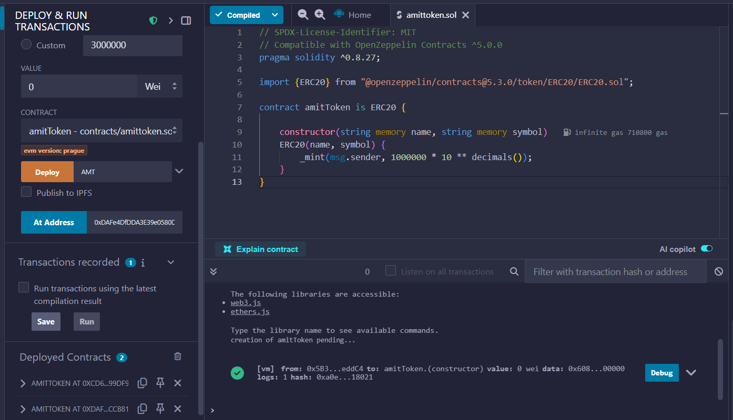

# * Softwares used

* REMIX IDE
* METAMASK
* **Testing Phase: Compilation of Code (error detection)**
* **Implementation Phase: Final Output (no error)**

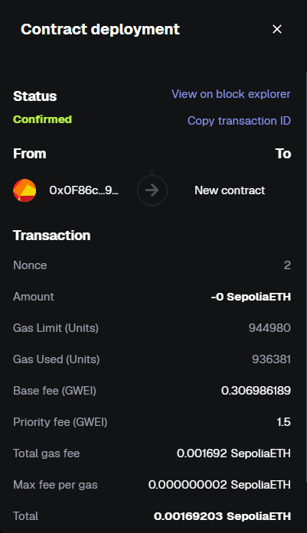

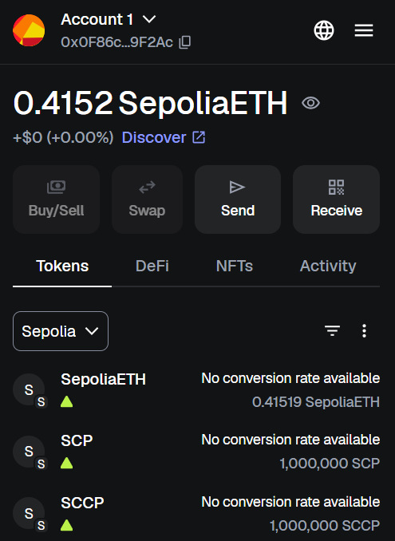

* **Implementation Phase: Final Output (no error)**

Applied and Action Learning

# * Observations

* Deploying a token locally is a crucial step for testing and development before launching on a public network.
* This process allows developers to verify the functionality of their smart contract without incurring real transaction costs or risking funds.
* This local setup is ideal for initial testing, enabling developers to interact with the token using a wallet like MetaMask connected to the local network.
* The local environment helps identify and fix issues such as reentrancy attacks or overflow problems before deployment on a testnet or mainnet.



|  |  |  |  |
| --- | --- | --- | --- |
| **Rubrics** |  |  |  |
| Concept | 10 |  |  |
| Planning and Execution/  Practical Simulation/ Programming | 10 |  |  |
| Result and Interpretation | 10 |  |  |
| Record of Applied and Action Learning | 10 |  |  |
| Viva | 10 |  |  |
| **Total** | **50** |  |  |

***Signature of the Student:***



***Signature of the Faculty:***